Tea Trivia

Did you know that what most Americans call “High Tea” is actually closer to an “Afternoon” or “Low” Tea? The idea of having “Tea” as a meal started as what was essentially a hearty dinner served with tea seated at “high” tables. Then, during the reign of Queen Victoria, the aristocracy started taking tea with light refreshments and sweets around 4:00pm seated on couches and chairs around coffee tables, thus creating “Low,” or Afternoon Tea.

Proper Tea Etiquette

- How to Stir your Tea: Move your spoon back and forth between the 12:00 and 6:00 positions, not around in a circle. Make sure the spoon does not hit the sides of the teacup so as to remain perfectly quiet!
- How to Hold a Teacup: To properly hold a teacup, pinch your index finger and thumb through the opening of the handle and let the handle rest on your middle finger- and no pinkies hanging out- and the other two fingers get tucked in under the middle finger.
- How to Drink: Sip your tea quietly- no slurping or gulping- and don’t use tea to wash down food. Set your teacup down between sips, don’t keep holding it.
- How to Eat: Enjoy your scone one small piece at a time, individually spreading cream and jam on each bite. Use the spoons provided for cream and jam to put a small amount of each on your plate- then use your own knife to spread them onto your bites of scone.
- How to Have Fun: You know better than we do! Sit back, savor your tea, and enjoy your time with friends. Also, check out our hat wall and snap some pictures! Make sure to tag @SpringTeaGarden
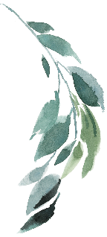
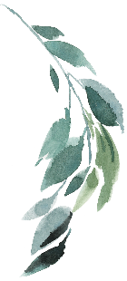

A La Carte
Create your own tea experience from our A La Carte Menu
DRINKS  Pot of Tea with Refills……………………………………  Flight of Tea – 3 Selections with Refills…………………  Glass of Lemonade OR Iced Tea with Refills…………..  Coffee - ea……Espresso $4………Gourmet Coffee….  Glass of Champagne – ea……………………………...  Champagne by the Bottle – ea…………………………  Mimosas by the bottle with OJ or Cranberry – ea…….. | $7  $15  $5  $5  $11  $22  $25 | SWEET  Scone with Cream & Jam - ea………………………  Seasonal Fruit Cup - ea…………..…………………  Bite Size Dessert - ea…………………….………….. | $6  $7  $3
 |  | TO GO  Scones To Go (1/2 Dozen)…………………………  Scones To Go with Cream & Jam (1/2 Dozen)……  Tea Bags To Go (1/2 Dozen)………….………….. | $24  $36  $12
SAVORY  Tea Sandwiches…………3 for $8.40………5 for…….  Garden Salad…………Petite $6……………Entrée…..  Cup of Soup……………………………………………. | $14.00  $12.50  $6
 |  | CATERING  Tea Sandwiches (25 pcs Tray) – ea…………………  Fresh Seasonal Fruit Salad (Serves 10-12) - ea……. | $62.50  $60.00

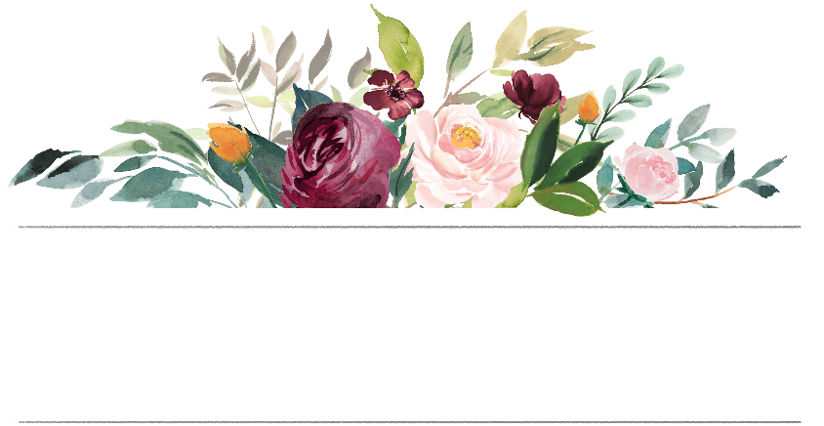

Menu
SANDWICHES
Avocado Cream Cheese | Caprese with Pesto | Cucumber Dill | Chicken Salad with Sun Dried Cranberries | Egg Salad
Gluten Free Options Available Upon Request & Availability +$5.00 per person

ADD A CUP OF SOUP TO ANY ORDER BELOW FOR +$5.00 | Soup of the Day
Spring Tea  A traditional afternoon tea with a variety of sweet and savory bites served on a tiered plate.  Toasted Scone  Served with Fresh Cream and Jam  Five Tea Sandwiches  Two Bite Size Desserts  Pot of Tea with Refills  $33.00  Garden Tea  A plant-based set perfect for a lighter lunch or guests with dietary restrictions.  Fresh Fruit Cup  Petite Salad  Pot of Tea with Refills  $20.00 | 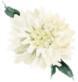  Royal Tea  Experience the luxury of afternoon tea with this three-course set fit for a queen!  Toasted Scone  Served with Fresh Cream and Jam  Five Tea Sandwiches  Two Bite Size Desserts  Pot of Tea with Refills  INCLUDES  Fresh Seasonal Fruit  Petite Garden Salad  Glass of Champagne  $45.00  Little Princess Tea  (Kids Menu Only – NO ADULTS)  A tea to delight guests ages 3-10 years old.  Fresh Fruit Cup  Toasted Scone  Served with Fresh Cream and Jam  Four Tea Sandwiches  Cucumber and PB&J  One Bite Size Dessert  Kids Pot of Tea, Hot Cocoa, or Lemonade  $20.00

Tea List

GREEN TEAS  Green tea is a longtime treasure of China and Japan and is gaining popularity in America. The best green tea leaves are heated or steamed right after harvest, preserving their all-natural flavor and resulting in a nourishing brew full of antioxidants.  Caffeine: Each cup has about half the caffeine of black tea.  Steep Time: 2-4 minutes  Moroccan Mint  Formosan gunpowder tea-a tightly rolled green leaf that “explodes” in hot water-and top-grade peppermint combines to create a refreshing cup.  Green Chai  Green tea is blended with spicy ginger, cinnamon and cardamom is finished with sweetness of fresh almonds.  This tea contains nuts.  Pomegranate  Fresh and crisp China green tea blended with organic hibiscus creates an ideal base for a splash of pomegranate in this uniquely refreshing ruby-hued cup.  Spring Cherry  The cheerful, fresh essence of cherries, combined with the sweet, earthy taste of green leaves.  Orange Spice  Green tea’s natural astringency is sweetened by mandarin oranges and finished off with deep, rich blend of cinnamon and cloves.  Spring Jasmine  Spring Jasmine is made of smooth China leaves naturally scented by layers of jasmine buds, lending it an intoxicating aroma and a piquant yet rounded cup |  | BLACK TEAS  Black tea is the most common tea in North America. It is produced when withered tea leaves are rolled and allowed to oxidize and dry, developing natural flavor, color, and body in the leaf.  Caffeine: Half the caffeine of coffee and twice that of green tea.  Steep Time: 3-5 minutes  Blackberry Sage  Finest quality tea leaves mingle with sweet, fragrant blackberries and cool, soothing white sage with a mild, head-clearing character.  British Breakfast  A robust blend of quality black leaves, hearty enough to make any Brit smile. A savory mixture of Indian, Sri Lankan and Kenyan leaves is great with a splash of milk.  Cranberry Blood Orange  The fruitful blend that helps you take on the day. Tart-sweet cranberries and sunny blood oranges bring forth flavor to savor.  Caramel Vanilla CuppaCake  Taste the decadent flavors of old-fashioned Southern yellow cake. This smooth premium black tea blend was inspired by the caramel cake in the movie "The Help."  Cinnamon Plum  This delicious cup begins with the zesty sing of cinnamon and finishes with the deep, romantic flavor of ripe plum. A complex yet soothing tea.  Earl Grey Fancy  This exceptional Earl Grey blend combines faint notes of bergamot orange with a lovely ceylon black tea leaf from Sri Lanka.  Ginger Peach  This best-selling tea offers the sweet lushness of a fancy peach with the tingle of spicy ginger. Fresh peach notes are complemented by a mild, zesty hint of ginger in this amber infusion.  Mango Ceylon  This favored tea is light, sweet & intoxicatingly fragrant. Mango & sunflower blossoms are blended with black tea leaves to produce an  uplifting cup. A favorite retreat for coffee lovers.  BLACK TEA CONTINUE NEXT COLUM… |  | Rose Petal  Delicate, young rose buds and petals mingle with sweet. An Elegant Victorian tradition.  Passion Fruit Papaya  Let the lush, sweet fruits of the tropics fill your cup; fine black tea with golden passion fruit and papaya, tart-sweet pineapple, and delicate sunflower petals.  Black Chai  Rich Imperial spices are combined with North Indian tea leaves to create a hearty.  Darjeeling  The smooth character of second-flush leaves layers with the deep, lush qualities of third-flush leaves for a round cup with full, balanced flavor.  Vanilla Almond  The smoothness of Madagascar vanilla beans takes over the first sip of this tea, sweetening the cup. Nutty almond follows, which sends it soaring to the realm of dessert. This tea contains nuts.  OOLONG TEAS  From its name to its distinctive flavor, oolong tea is all allure. With origins in Taiwan and southeast China, oolong tea is produced when tea leaves are oxidized in direct sunlight until they give off their pleasant fragrance, somewhere between apples, orchids, and peaches.  Caffeine: Midway between black tea and green tea  Steep Time: 5-7 minutes  Ti Kuan Yin  Strengthen the Sprit Tea-Famous oolong from Fujian province in China is known for its fresh, orchid flavor& Clean finish. Large, iron-colored leaves can be infused many times over.  Peach Blossom  Grown along winding mountain streams in China's Fujian province, this tea produces a cup with a bright flavor and pleasing flowery finish.
 |  |  | 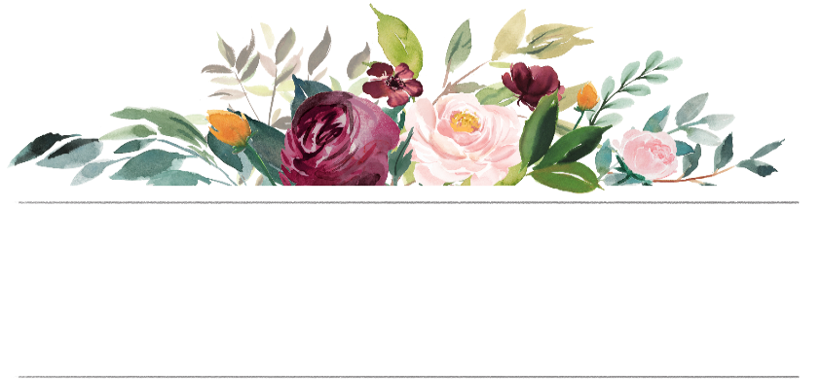
 |  | Tea List
WHITE TEAS  This delicacy is the most minimally processed of all tea varietals. This precise technique produces a subtle cup with mellow, sweet notes. 100% natural white tea bags have become a staple of high-end tea collections, a new favorite flavor for connoisseurs.  Caffeine: Very little caffeine – about half that of green tea.  Steep Time: 2-3 minutes  Emperor’s White  This tea is revered for its subtlety, complexity and mellow, sweet notes. A truly delicate and light cup of tea.  ROOIBOS TEAS -DECAF  Rooibos (pronounced ROY-boss) is a dramatic red tea made from a South African herb that contains polyphenols and flavonoids. Often called “African redbush tea,” Rooibos herbal tea delights the senses and along with all the same health benefits you expect out of a top-tier tea.  Caffeine: None!  Steep Time: 5-7 minutes  Red Chai  Explorer’s Rooibos Herb Tea. Blended with a delicious mélange of other herb and spices: cinnamon, orange peel, ginger, cardamom seeds, Chinese star anise, cloves, and black pepper.  Good Hope Vanilla  We offer you Good Hope Vanilla, a blend of rooibos and sweet, fragrant vanilla beans. This caffeine-free infusion is sweet, satisfying and good all day long.  Red Velvet Cuppa Chocolate  Have your cake and sip it too! Chocolate and beet root bits combine to taste just like the classic red velvet cake. This is the perfect cup to accompany birthdays and other celebrations. |  | HERBAL TEAS - DECAF  Did you know that “herbal teas” are not officially teas? In the purest sense, only the leaves and buds of Camellia Sinensis, the plant that gives us black, oolong, green, and white tea should be called tea. Fun facts aside, herbal teas offer range of health benefits and are just plain delicious to drink!  Caffeine: None!  Steep Time: 5-7 minutes  Almond Coconut Macaroon  The Aroma of lightly toasted almonds and touch of coconut add a touch of  sweetness to warm, earthy, rooibos tea  Blueberry Lavender  Daily beaty ritual with juicy blueberry and calming lavender caffeine-free herbal tea  Cardamom Cinnamon  Native to the shadier regions of India & Ceylon, cardamom has a gentle, airy taste of the forest itself - reminiscent of ginger with a pinch of pine. Cinnamon brings a spicy depth.  Chamomile Citrus  Made with soothing chamomile flowers and subtle slices of citrus fruit, this tea is a refreshing infusion perfected to curl up with and savor by the sip.  Hibiscus Watermelon  Sweet-tart Nigerian hibiscus blossoms infuse a flavor reminiscent of berry and bright citrus. Combined with the cool taste of ripe watermelon, this tea makes a perfect splash of refreshment.  Hibiscus Coconut  Cooling coconut partners with tangy Nigerian hibiscus  Orange Ginger Mint  Spicy yet soothing, ginger pairs with orange bergamot mint and other uncommon botanicals for soft and luscious.  Mint Mélange  A well-rounded infusion with sweet lingering notes that captures the cool and pure essence of mint. Round-bodied, with a sweet, minty finish and aromas of fresh mint.  Raspberry Rose Hibiscus  A Romantic blend of tangy Nigerian hibiscus, ripe raspberries, and delicate rose petals. A fruity, floral infusion.  HERBAL TEA CONTINUE NEXT COLUM... |  | Wild Berry Hibiscus  A vibrant and sweet herbal infusion of  Tart hibiscus blended with a lush mix of elderberries and flavors or ripe fruits.  BLACK TEAS - DECAF  Decaf tea gives you all the flavor and enjoyment you expect from a good cup of tea, but spares you the caffeine content. The decaffeination process is all-natural and eco-friendly.  Caffeine: Trace amounts  Steep Time: 3-5 minutes  Apricot - Decaf  The tart-sweet, musky flavor lends itself to the deep, rich notes of naturally decaffeinated black tea. Plentiful in beta carotene and fiber, apricots keep eyes bright and aid in digestion.  Earl Grey Fancy - Decaf  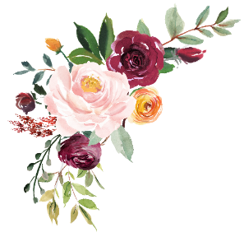  More of a Good Thing Tea - Our exceptional blend of this classic tea uses a superior, light liquoring leaf combined with top-grade, pure bergamot oil.  Not sure what tea to order?  Try one of our Guest Favorites!  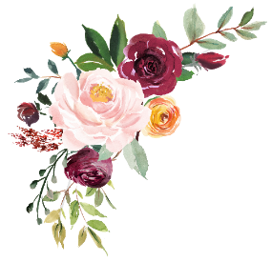

FAQ

- Do I have to make a reservation? - Yes, we do require a reservation for Saturday’s and Sundays as our Spring Tea Garden Public Room may be reserved for a private event
- How do make a Reservation: Please call us to speak with a representative to make your reservation and confirm availability.
- What if my group size increases or decreases: If your group size increases or decreases, call us up to 1 day prior to your reservation to make the table adjustments
- What if my group size increases to 7 or more guests? For groups of 7 or more guests, we require a $100.00 retainer to reserve your table

